Grievance Cell For Organization
- Project Structure

Grievance_cell/
├── Department/
│ ├── APIs.py
│ ├──crud.py
│ ├── models.py
│ └── schemas.py
├── User/
│ ├── APIs.py
│ ├──crud.py
│ ├── models.py
│ └── schemas.py
├── Grievances/
│ ├── APIs.py
│ ├──crud.py
│ ├── models.py
│ └── schemas.py
├── Comments/
│ ├── APIs.py
│ ├──crud.py
│ ├── models.py
│ └── schemas.py
├── auth.py
├── dependencies.py
├── roles.py
├── database.py
└── main.py

- Roles & Authorization

Role Enum | Description
user | Can sign up, log in, create grievances, add/view own comments/grievances
employee | Can view/apply to assigned grievances, add comments
admin | Can create departments and assign grievances to employees
super_admin | Full access—manage departments, users, assignments

- API Endpoints

  - Authentication Endpoints
Method | Path | Body | Response | Description
POST | /signup | { email, password, department_id, role } | UserFull | Create user and return full details
POST | /login | Form: username, password | { access_token, token_type } | JWT login

  - User Endpoints
Method | Path | Body | Response | Access Roles | Description
POST | /users/ | UserCreate | UserFull | admin, employee, super_admin | Create new user
GET | /users/ | — | List of UserLimited / UserFull | All roles | List users (limited info for user)
GET | /users/{id} | — | UserLimited or UserFull | All roles | Get user detail (limited if not self/admin)

  - Department Endpoints
Method | Path | Body | Response | Access Roles | Description
POST | /departments/ | DepartmentCreate | DepartmentOut | admin, super_admin | Create a department
GET | /departments/ | — | List of DepartmentOut | employee, admin, super_admin | List departments

  - Grievance Endpoints
Method | Path | Body / Query | Response | Access Roles | Description
POST | /grievances/ | GrievanceCreate | Grievance | user only | Create grievance; auto adds ticket_id, status pending
GET | /grievances/ | — | List of Grievance | All roles (filtered) | Users see own, employees see assigned, admin/super admin see all
POST | /grievances/assign | — | 204 No Content | admin, super_admin | Distributes pending grievances evenly to employees
POST | /grievances/{id}/resolve | ResolverSchema | Full Grievance | employee, admin, super_admin | Mark grievance solved/not_solved, sets resolved_by, resolved_at

  - Comments API
Method | Endpoint | Description
POST | /comments/ | Post a new comment
GET | /comments/grievance/{grievance_id} | View comments on grievance

- Database
In this Project we incorporated SQLite Database
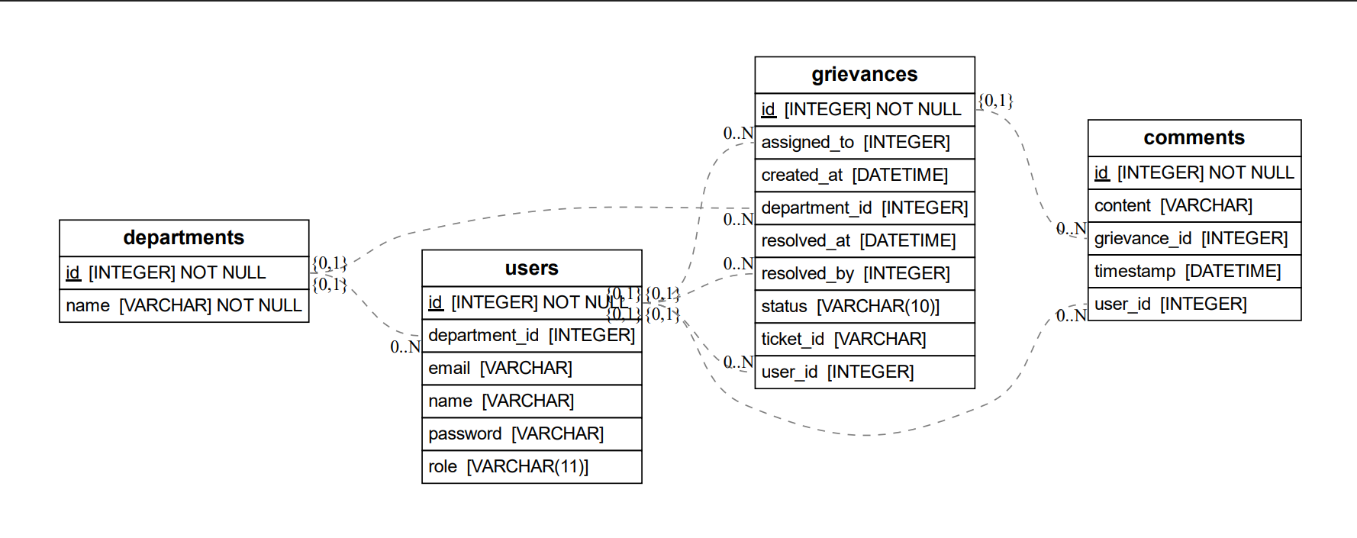
Entity Relationship Diagram For Grievance.db
  - Users Tables

Field | Type | Description
id | Integer PK | Auto-incrementing user ID
email | String | Unique user email
password | String | Hashed password using bcrypt
role | Enum | Role in the system (user, employee, etc.)
department_id | ForeignKey | Links to departments.id

Relationships:

- Many users → One department

  - departments Table
Field | Type | Description
id | Integer PK | Unique identifier for each department
name | String | Department name

Relationships:
- One department → Many users
- One department → Many grievances

  - Grievances Table

Field | Type | Description
id | Integer PK | Unique grievance ID
title | String | Short description of grievance
description | String | Full grievance explanation
ticket_id | String | Auto-generated unique ticket ID (UUID)
status | Enum | pending, resolved, not_resolved
created_at | DateTime | Timestamp when the grievance was created
resolved_at | DateTime | Timestamp when resolved
user_id | ForeignKey | Who created the grievance (User)
department_id | ForeignKey | Which department it's assigned to
assigned_to | ForeignKey | Which employee is assigned (nullable)
resolved_by | ForeignKey | Who resolved the grievance (nullable)

Relationships:
- One grievance → One user
- One grievance → One department
- One grievance → One assigned employee (nullable)
- One grievance → One resolver (nullable)

  - Comments Table

Field | Type | Description
id | Integer PK | Unique comment ID
content | Text | Comment body
timestamp | DateTime | When the comment was made
user_id | ForeignKey | Author of the comment
grievance_id | ForeignKey | Related grievance

- CRUD

5.1 User
This module manages user-related operations, including user creation, authentication, and fetching user records. It integrates department assignment logic and password hashing for security.
Functions:
- get_password_hash(password: str) -> str
Hashes a plain-text password using bcrypt for secure storage.
- verify_password(plain: str, hashed: str) -> bool
Verifies a plain-text password against the hashed version.
- create_user(db: Session, user: schemas.UserCreate)
Registers a new user. If no department is specified, it assigns or creates a default "OTR" department. The password is securely hashed before storing.
- authenticate_user(db: Session, email: str, password: str) -> Optional[models.User]
Validates user credentials during login. Returns user object if authentication succeeds.
- get_users(db: Session, role_filter: List[str] = None)
Retrieves all users. If role_filter is provided, returns only users matching the specified roles.
- get_user(db: Session, user_id: int)
Fetches a single user by their unique ID.
5.2 Department Module – crud.py
This module handles creation and retrieval of department records.
Functions:
- create_department(db: Session, department: schemas.DepartmentCreate)
Creates and stores a new department using the provided department name.
- get_departments(db: Session)
Retrieves all departments stored in the database.

5.3 Grievance Module – crud.py
This module is responsible for all grievance-related database actions, including creating, assigning, retrieving, resolving, and transferring grievances.
Functions:
- create_grievance(db: Session, grievance: schemas.GrievanceCreate, user_id: int)
Creates a new grievance entry linked to a user and department. Generates a unique ticket ID for tracking.
- assign_grievances_to_employees(db: Session)
Distributes all unassigned grievances to employees in a round-robin fashion.
- get_grievances_by_user(db: Session, user_id: int)
Retrieves all grievances submitted by a specific user.
- get_grievances_by_employee(db: Session, employee_id: int)
Retrieves grievances assigned to a specific employee.
- get_all_grievances(db: Session)
Retrieves all grievances in the system without filters.
- resolve_grievance(db: Session, grievance_id: int, resolver_id: int, solved: bool = True)
Updates the status of a grievance to either resolved or not resolved. Also records who resolved it and when.
- transfer_grievance_department(db: Session, grievance_id: int, new_department_id: int)
Transfers a grievance to another department using the grievance’s numeric ID.
- transfer_grievance_by_ticket_id(db: Session, ticket_id: str, new_department_id: int)
Transfers a grievance to another department using the grievance’s ticket ID.

5.4 Comment Module – crud.py
This module handles operations related to user comments on grievances.
Functions:
- create_comment(db: Session, comment: schemas.CommentCreate)
Creates a new comment and automatically attaches the current timestamp to it.
- get_comments_by_grievance(db: Session, grievance_id: int)
Retrieves all comments associated with a specific grievance.

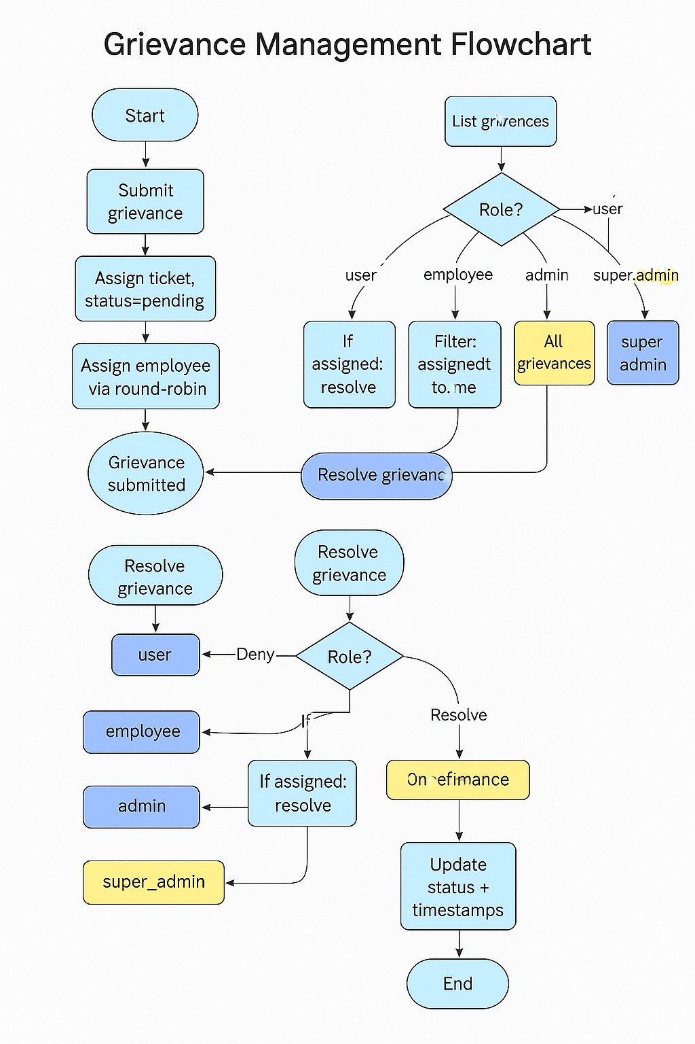

Over all Workflow of System
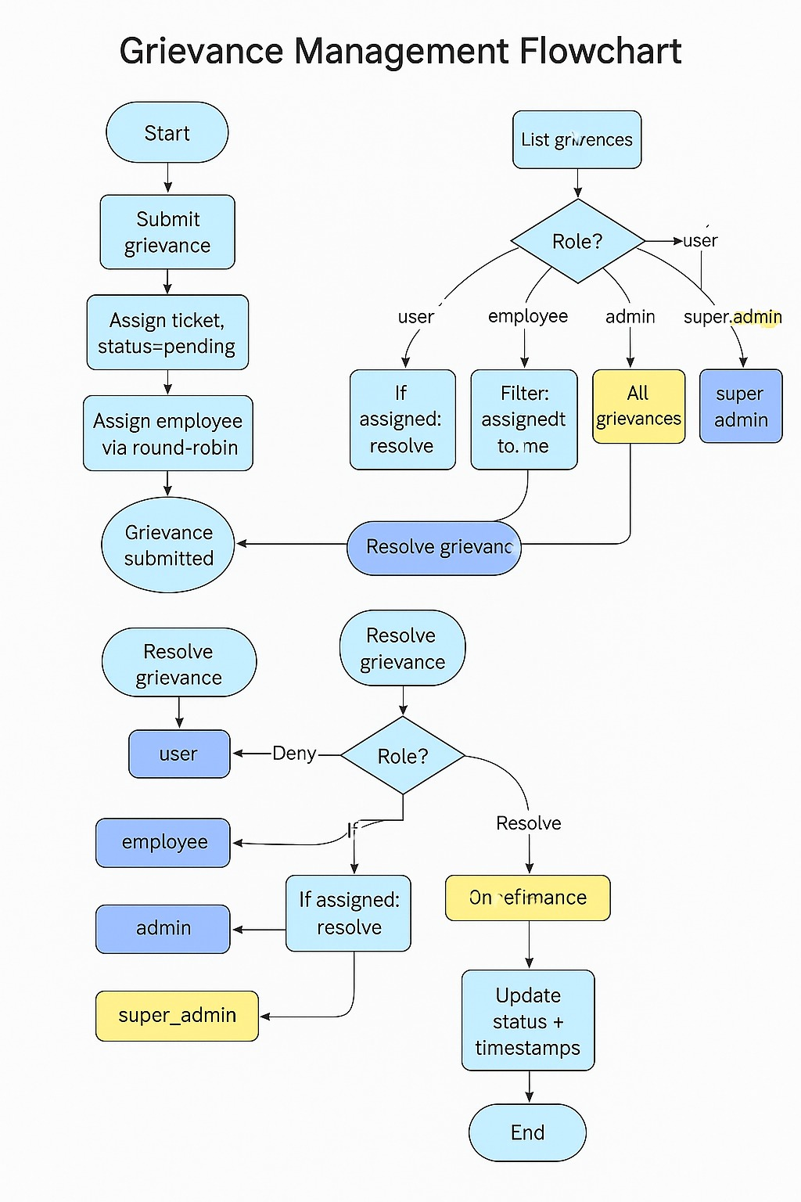
Separated Workflow Of All Modules

User Module
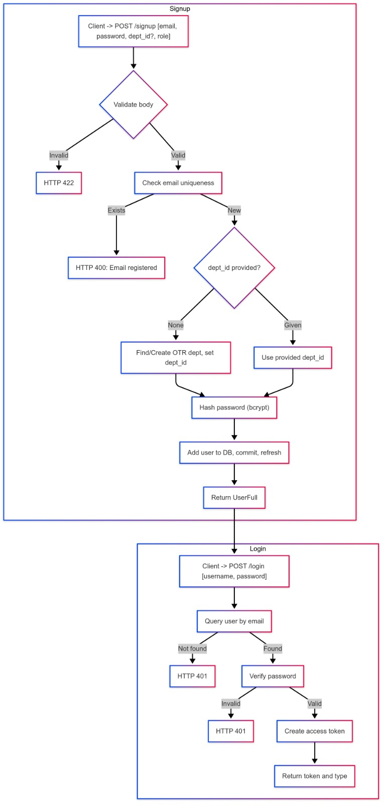
Department Module
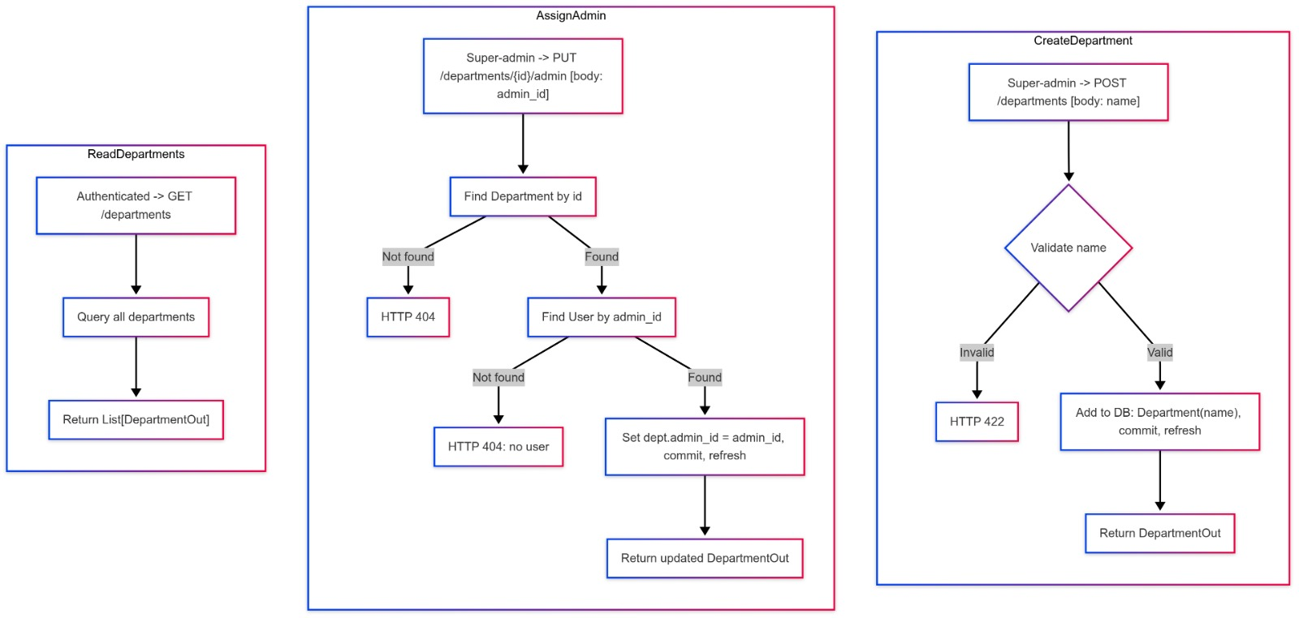
Comment Module
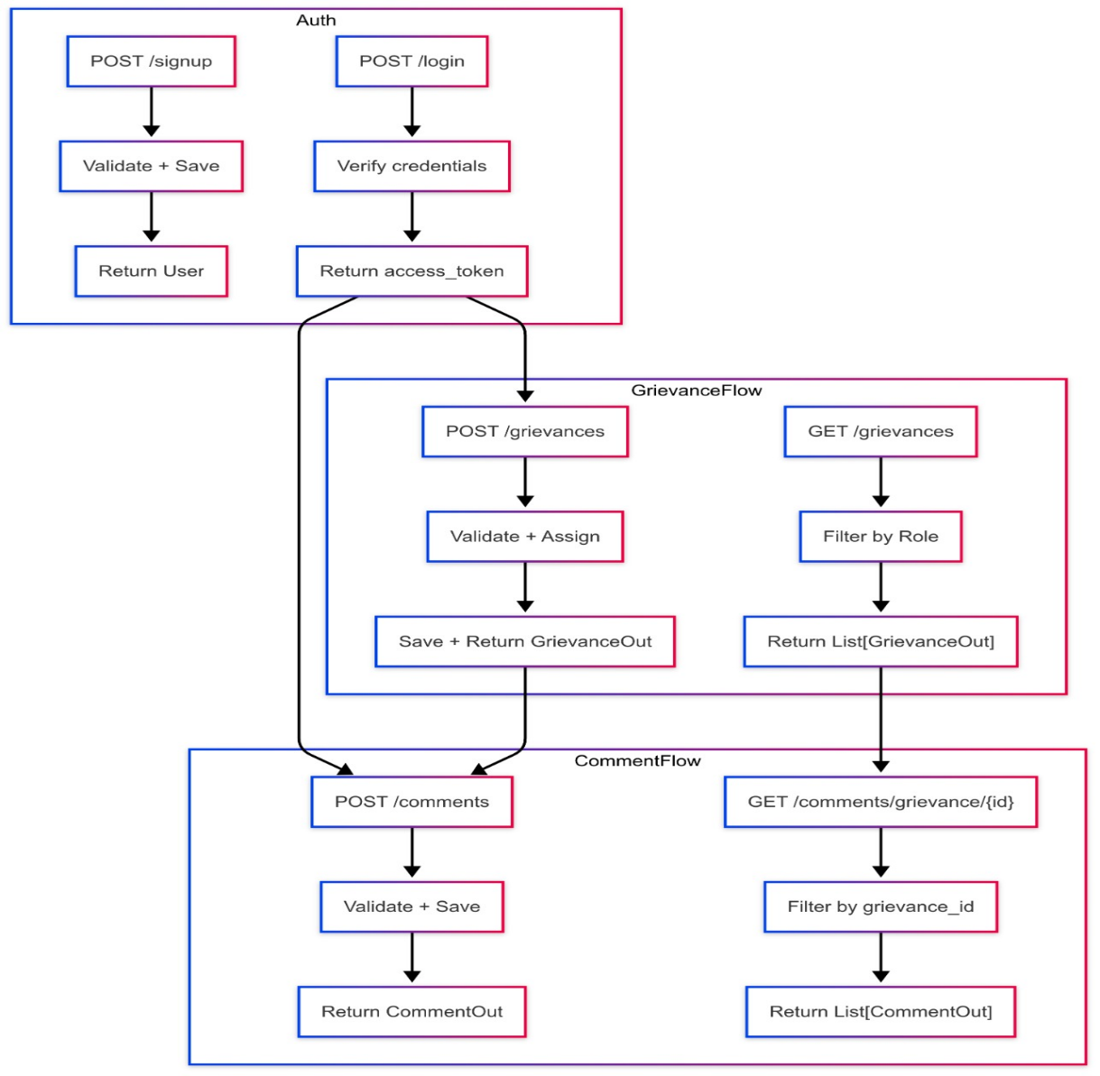
Super Admin Role
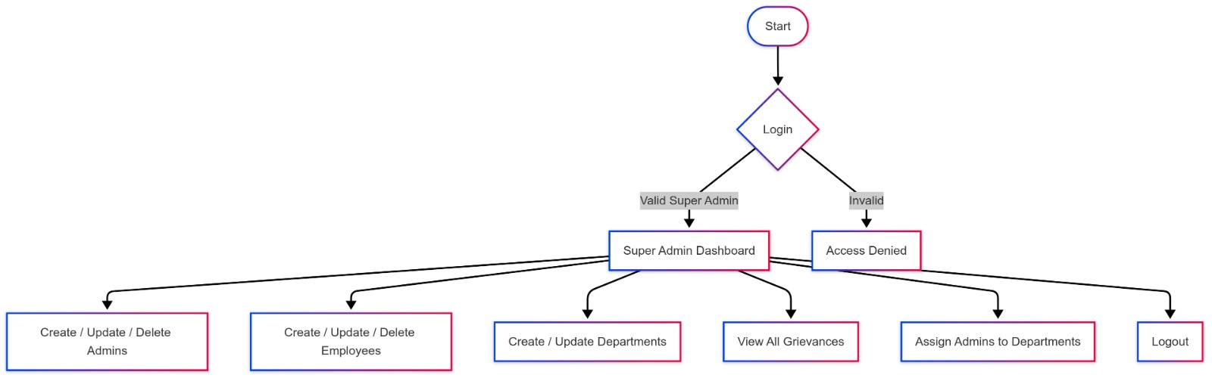
Admin Role
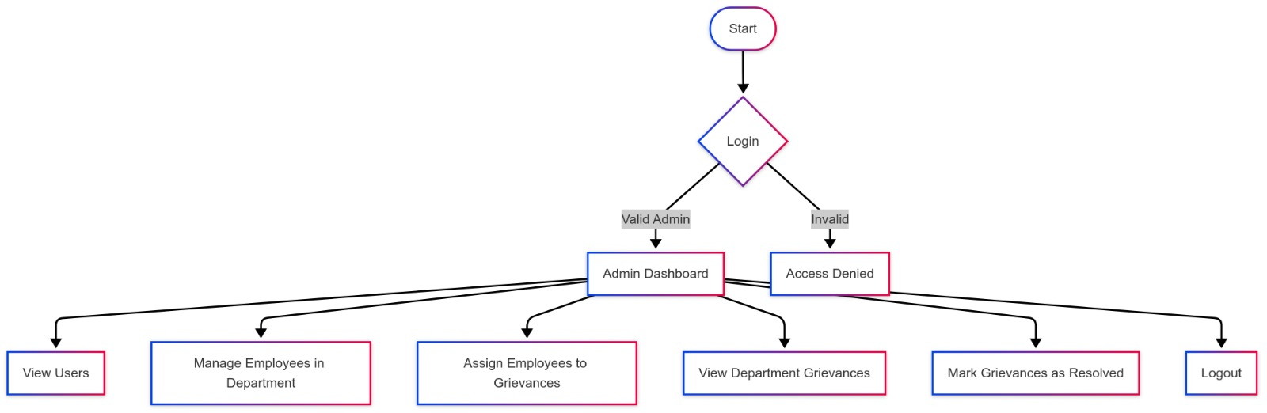
Employee role
